PIZZA SALES SQL QUERY

KPI
1)Total Revenue
select sum(total_price) as total_revenue from pizza_sales;

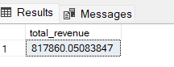

2)Average Order Value
select sum(total_price)/count(distinct order_id)as Avg_order_value from pizza_sales;
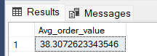

3)Total Pizzas Sold
select sum(quantity)as Total_pizza_sold from pizza_sales;
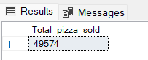

4)Total Order
select count(distinct order_id)as Total_order from pizza_sales;
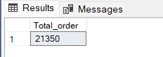

5)Average Pizzas Per Order
select cast(cast(sum(quantity)as decimal(10,2))/
cast(count(distinct order_id)as decimal(10,2)) as decimal(10,2))as Avg_pizza_order from pizza_sales;

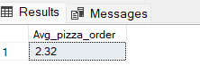

6)Daily Trend For Total Orders
select datename(DW,order_date) as order_day,count(distinct order_id)as total_orders
from pizza_sales
group by datename(DW,order_date)

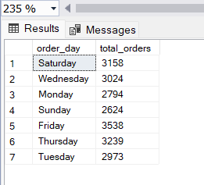

7)Monthly Treand for Orders
select datename(month,order_date)as month_name,count(DISTINCT order_id)as total_order
from pizza_sales
group by DATENAME(month,order_date)
order by total_order desc;
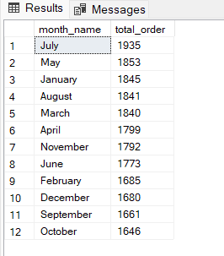

8) % of Sales by Pizza Category
select pizza_category,sum(total_price)as total_sales,sum(total_price)*100/(select sum(total_price) from pizza_sales where month(order_date)=1)as pct
from pizza_sales
where month(order_date)=1
group by pizza_category;
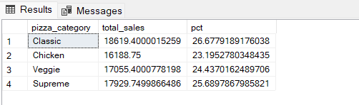

9) % of Sales by Pizza Size
select pizza_size,cast(sum(total_price) as decimal(10,2))as Total_Sales,cast(sum(total_price)*100/
(select sum(total_price) from pizza_sales where DATEPART(quarter,order_date)=1
)as decimal(10,2))as PCT
from pizza_sales
where DATEPART(quarter,order_date)=1
group by pizza_size
order by PCT desc

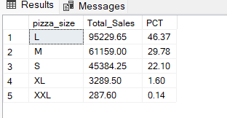

10) Top 5 Pizzas by Revenue
select top 5 pizza_name,sum(total_price) as total_revenue from pizza_sales
group by pizza_name
order by total_revenue desc
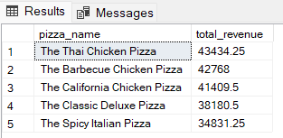

11) Total Pizzas Sold by Pizza Category
SELECT pizza_category, SUM(quantity) as Total_Quantity_Sold
FROM pizza_sales
WHERE MONTH(order_date) = 2
GROUP BY pizza_category
ORDER BY Total_Quantity_Sold DESC
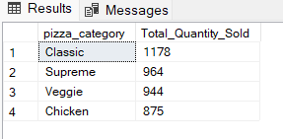
12) Bottom 5 Pizzas by Revenue
SELECT Top 5 pizza_name, SUM(total_price) AS Total_Revenue
FROM pizza_sales
GROUP BY pizza_name
ORDER BY Total_Revenue ASC
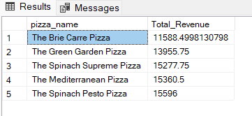

13) Top 5 Pizzas by Quantity
SELECT Top 5 pizza_name, SUM(quantity) AS Total_Pizza_Sold
FROM pizza_sales
GROUP BY pizza_name
ORDER BY Total_Pizza_Sold DESC

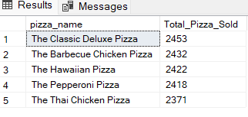

14) Bottom 5 Pizzas by Quantity
SELECT TOP 5 pizza_name, SUM(quantity) AS Total_Pizza_Sold
FROM pizza_sales
GROUP BY pizza_name
ORDER BY Total_Pizza_Sold ASC

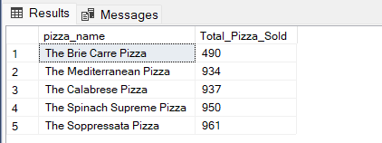

15) Top 5 Pizzas by Total Orders
SELECT Top 5 pizza_name, COUNT(DISTINCT order_id) AS Total_Orders
FROM pizza_sales
GROUP BY pizza_name
ORDER BY Total_Orders DESC
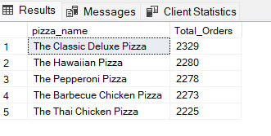

16) Borrom 5 Pizzas by Total Orders
SELECT Top 5 pizza_name, COUNT(DISTINCT order_id) AS Total_Orders
FROM pizza_sales
GROUP BY pizza_name
ORDER BY Total_Orders ASC
